NAME:

MATH125: Unit 1 Individual Project Answer Form

Mathematical Modeling and Problem Solving

ALL questions below regarding painting a bedroom must be answered. Show ALL step-by-step calculations, round all of your final answers correctly, and include the units of measurement. For full credit, all explanations must be given in the spaces provided. Upload this modified Answer Form to the Unit 1 Individual Project. Make sure that you submit your work in a modified Microsoft Word document; scanned or handwritten work will not be accepted. If you need assistance, please contact your course instructor.
All of the commonly used formulas for geometric objects are just the mathematical models of the characteristics of physical objects. For example, because a basketball is approximately a sphere, it can be partially modeled by its distance from one side through the center (radius, r) and then to the other side by the diameter formula for a sphere, D = 2r.
For the two-dimensional variables of length (L) and width (W), the perimeter and area formulas for a rectangle are mathematical models for the distance around a rectangle (perimeter, P) and the region enclosed by the sides (area, A), respectively, as follows:
P = 2L + 2W and A = L × W
Along with another variable, height (H), a three-dimensional rectangular prism’s volume and surface area can be measured. For example, the formulas for a common closed cardboard box’s inside space (volume, V) and outside covering (surface area, SA) are, respectively, as follows:
V = L x W x H and SA = 2(L x W) + 2(W x H) + 2(L x H)
For this assignment, follow Pólya’s principles to solve your problems, as follows:
- Understand the problem.
- Devise a plan.
- Carry out the plan.
- Take a look back.
Include the following in your assignment:
- Explain your interpretation of what the problem is about.
- Develop and write down a strategy for solving this problem; show the steps in the correct order for your attempted solution.
- Did your strategy actually solve the problem? How do you know?
- Suppose that your solution did not solve the problem—what would your next action be?

Painting a Bedroom
The walls and ceiling inside your bedroom need to be painted. To save money, you decide that you will paint the bedroom yourself. Use the following information to solve this problem:
- The bedroom is 17 feet long by 18 feet wide, and the ceiling is 9 feet high.
- The inside of the bedroom door will be painted the same color as the walls.
- Two coats of paint will be applied to all of the painted surfaces.
- The room has one window, measuring 3 feet, 9 inches by 4 feet, which will not be painted.
Pólya’s Principle Step 1: Understand the Problem
- Describe in detail what you understand the problem to be. In other words, what problem will you need to solve? Is there enough information to enable you to find a solution to your problem?
Show your work here: (10 points)

- Discuss different ways to construct the room that will be painted. Are there any restrictions on where the window and door will be located? Will the overall amount of paint that is needed change based on where these are placed in the room?
Show your work here: (10 points)

- List the facts that you know. First, find the room dimensions in feet that make a good model for this situation. One strategy would be to sketch the room as follows. Please use this model to complete the following table below. (3 points)
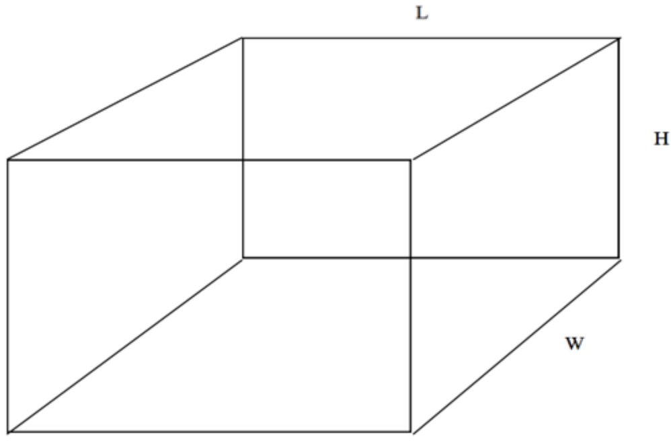

 | Side Answers
Length | ?
Width | ?
Height | ?

- Using the measurements diagrammed above, label all of the rectangular faces in feet in the following table: (5 points)

 | Face Dimensions
Ceiling | ? | ?

 | Face Dimensions
Left Wall | ? | ?
Right Wall | ? | ?

 | Face Dimensions
Front Wall | ? | ?
Back Wall | ? | ?

- Because all of the ending values are given in feet, find the window dimensions in feet. Convert the length of 3 feet, 9 inches strictly into feet. The answer should be in decimal format. Do not round. Note that 12 inches are equal to 1 foot.

 | Face Dimensions
Window | ? | ?

Show your work here: (5 points)
Diagram 2
Wall
14.25’ by 8’

Pólya’s Principle Step 2: Devise a Plan
- Using Pólya’s technique for problem solving, describe your plan to solve this problem in detail. In other words, what is your solution strategy? Discuss the strategy, steps, formulas, and procedures that you will use to answer this problem.
Show your work here: (10 points)

Pólya’s Principle Step 3: Carry out the Plan
- Using the formula concepts and dimensions above, find the bedroom’s total painted surface area for all of the walls.

Show all of the calculations step by step, including the units of measurement, and round your final answer up to the nearest whole measurement unit in the following table:

 | Answer
Total Painted Wall Surface Area With One Coat of Paint | ?

Show your work here: (8 points)

- Do not forget to subtract the window’s area. Also, determine the surface area for two coats by doubling the painted wall’s surface area.

Show all of the calculations step by step, including the units of measurement, and round your final answers up to the nearest whole measurement unit in the following table:

 | ANSWERS
Window’s Area | ?
One Coat of Wall Paint Excluding the Window’s Area | ?
Painted Wall Surface Area With Two Coats of Paint | ?

Show your work here: (8 points)

- Using the formulas, concepts, and dimensions above, find the ceiling’s painted surface area, including the surface areas for one and two coats.

Show all of the calculations step by step, including the units of measurement, and round your final answers up to the nearest whole measurement unit in the following table:

 | Answers
Painted Ceiling Surface Area With One Coat of Paint | ?
Painted Ceiling Surface Area With Two Coats of Paint | ?

Show your work here: (8 points)

- Combining the answers from above, find the total painted surface area, including both coats for the walls and ceiling.

Show all of the calculations step by step, including the units of measurement, and round your final answer up to the nearest whole measurement unit in the following table:

 | Answer
Total Painted Surface Area With Two Coats of Paint | ?

Show your work here: (5 points)

- Assuming that you can paint 100 square feet per hour, what will be the work time needed to paint your bedroom?

Show all of the calculations step by step, including the units of measurement, and round your final answer off to the nearest whole hour amount in the following table:

 | Answer
Painting Time for the Walls and Ceiling | ?

Show your work here: (8 points)

Pólya’s Principle Step 4: Take a Look Back
- Did this strategy actually solve the problem? How do you know? Demonstrate that your solution is correct. In other words, explain why the values that you have created are the best times for the job. Was this the best way to solve this problem? If you had to do this again, what would you do differently? What would you do the same? Show your work here: (10 points)

