NAME:

MATH125: Unit 4 Individual Project Answer Form

Counting Techniques
ALL questions below must be answered. Show ALL step-by-step calculation. Upload this modified Answer Form to the Unit 4 Individual Project. Make sure you submit your work in a modified MS Word document; handwritten work will not be accepted. If you need assistance, please contact your course instructor.

Part A: Combinations and Permutations
- Differentiate between permutations and combinations. How are they different? What is the formula for each? (15 points total for Question 1)

How are they different?  (5 points) | ?

Permutation Formula  (5 points) | ?

Combination Formula  (5 points) | ?

- Each state has a standard format for license plates that includes a set number of alphanumeric characters. For this assignment, you can insert a picture of your state’s non-personalized license plate or provide a sample of the format in text. (20 points total for Question 2)

Your State’s Name  (1 point) | ?

Picture of a License Plate from Your State  (or a Sample)  (1 point) | ?

Describe the Character Rule for Your State’s Non-personalized License Plates  (1 point) | ?

  - Determine the number of different license plates that can be created using the following format. Assume that a license plate consists of seven alphanumeric characters using numbers (0–9) and capital letters (A–Z). Find how many unique license plates can be printed using any of the 36 alphanumeric characters without duplication in each of the seven alphanumeric characters, i.e., no alphanumeric character appears more than once in any license plate. (This question is NOT related to your state’s license plates in the initial 3 parts above).

Is this a permutation or combination? Why?  (2 points) | ?

What formula from Question 1 will you use to solve the problem?  (1 point) | ?

Number of unique license plates that can be printed:  (2 points) | ?

Show your work here (2 points):

  - You and a friend are witnesses of a car accident in your state. But you can only remember a few of the first alphanumeric characters on the license plate.

How many alphanumeric characters do you remember?  (1 point) | ?  (Select a number from 2 to 5)

What are the characters at the beginning?  (1 point) | ?

How many license plates start with these alphanumeric characters?  (2 points) | ?

Show your work here (2 points):

How many license plates have been eliminated?  (2 points) | ?

Show your work (2 points):

- Your community has asked you to help the YMCA sports director organize a season of sports. You need to put together the teams. For the soccer teams, athletes signed up for one of three different age groups (Little Tykes, Big Kids, and Teens). (15 points total for Question 3)
Is this a permutation or combination? Why?  (2 points) | ?

What formula from Question 1 will you use to solve the problem?  (1 point) | ?

How many kids signed up for “Little Tykes”?  (1 point) | ?  (Select a multiple of 10, of at least 20)

How many kids signed up for “Big Kids”?  (1 point) | ?  (Select a multiple of 10, of at least 20)

How many kids signed up for Teens?  (1 point) | ?  (Select a multiple of 10, of at least 20)

How many total students signed up for soccer?  (1 point) | ?  (enter total form the three groups above)

Use the formula and values, from question above, to answer the following:
How many different ways can you create teams of 10 for the “Little Tykes” grade level?  (2 points) | ?

Show your work here: (2 points)

If age levels did not matter, how many different ways can you create teams of 10 from the total number of soccer players?  (2 points) | ?

Show your work here: (2 points)

Part B: Probabilities and Odds
- For this set of exercises, you will need a single standard six-sided die. If you do not have one, you can use a virtual die: https://www.random.org/dice/ (40 points total for Question 4)

  - First, differentiate between odds and probability.

How are odds and probability different?  (2 points) | ?

What is the odds in favor ratio?  (3 points) | ?

What is the probability of an event ratio?  (3 points) | ?

What are the odds of rolling a three (use the proper ratio from above)? Simplify all fraction answers.  (2 points) | ?

What is the theoretical probability of rolling a three (use the proper ratio from above)? Simplify all fraction answers.  (2 points) | ?

  - Reflect on the previous question’s answer outcome. First, convert the fraction to a percent.

 | Percent Probability
Theoretical Probability (Rounded to the nearest whole percent.)  (2 points) | ?

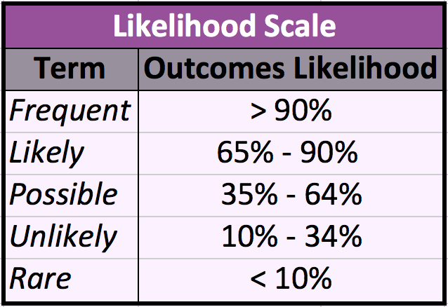

Next, use the likelihood scale table above to select the term that best describes your answer.
 | Likelihood Scale
Term  (2 points) | ?

  - What if someone challenged you to never roll a 3? If you were to roll your single six-sided die 18 times, what would be the theoretical probability of never getting a three?
Also, list the likelihood scale term from the table above.
 | Percent Probability
Solution  (Rounded to the Nearest Whole Percent)  (2 points) | ?
Likelihood Scale Term  (2 points) | ?

Show your work here: (2 points)

  - After 18 rolls, what would be the theoretical probability of getting a three on at least one of those rolls? Also, list the likelihood scale term from the table above.
 | Percent Probability
Empirical Probability  (Rounded to the Nearest Whole Percent)  (2 points) | ?
Likelihood Scale Term  (2 points) | ?

Show your work: (2 points)

What do you notice about the answers for parts c and d above?  (2 points) | ?

  - Roll the die 18 times and keep track of what is rolled in the table below. Remember, if you do not have one, you can use virtual dice: https://www.random.org/dice/ (2 points)

Roll # | Dice | Roll # | Dice | Roll # | Dice
Roll 1 | ? | Roll 7 | ? | Roll 13 | ?
Roll 2 | ? | Roll 8 | ? | Roll 14 | ?
Roll 3 | ? | Roll 9 | ? | Roll 15 | ?
Roll 4 | ? | Roll 10 | ? | Roll 16 | ?
Roll 5 | ? | Roll 11 | ? | Roll 17 | ?
Roll 6 | ? | Roll 12 | ? | Roll 18 | ?
  - Based on your die rolls, what is the experimental probability of rolling a three, out of 18 rolls? Also, list the likelihood scale term from the table above.
 | Percent Probability
Experimental Probability  (Rounded to the Nearest Whole Percent)  (2 points) | ?
Likelihood Scale Term  (2 points) | ?

Show your work here: (2 points)

With regard to the likelihood scale terms for each, how did this differ from both the theoretical and empirical probabilities?  (2 points) | ?

