MATH 233 Unit 5 Individual Project
NAME (Required): _____________________________
In this IP assignment, you will have a choice between two different Unit 5 IP assignments. Complete only ONE of the following two assignment choices.
Unit 5 IP Assignment Choice 1
The Internet is defined as a worldwide interconnection of individual networks operated by governments, industries, academia, and private parties (Internet World Stats, 2015). As the Internet grows and becomes more accessible to many people in the world, there is an increasing interest in forecasting its number of users as it helps improve the technology and its security.
In a recent study, researchers found that the rate of change of Internet users in the world (in millions) is modeled by the function
$$P^{'}\left(x\right)=0.24x^{2}+4.12x+25.49$$
where x is the number of years from 1994.
For the questions that require calculations, be sure to show your work details. If applicable, round your final answers to the nearest hundredth (2 digits after the decimal point) to receive full credit. For critical thinking questions, explain in detail how the answers were determined.
- Using integration on$P'(x)$, find the function P(x) that predicts the number of Internet users in the world $x$ years after 1994. (Note: Since this is an indefinite integral, do not forget to add a constant of integration, C, in your final answer.) Show your work details.

- Based on the first letter of your last name, calculate the value of C from #1 by choosing an ordered pair (x, P(x)) from the table below. Show your work details.
First letter of your last name | x (years from 1994) | P(x) (in millions)
A–B | 6 | 361
C–D | 7 | 513
E–F | 8 | 587
G–H | 9 | 719
I–J | 10 | 817
K–L | 11 | 1,018
M–N | 12 | 1,093
O–P | 13 | 1,319
Q–R | 14 | 1,574
S–T | 15 | 1,802
U–V | 16 | 2,267
W–X | 17 | 2,497
Y–Z | 18 | 2,802
- From your answers in #1 and #2, state the mathematical model P(x) (in millions) that will predict the number of Internet users in the world.

- Using P(x), complete the following table. Show the work details for full credit.
Year | x | Predicted Number of Internet Users $P(x)$ (in millions)
2016
2018
2020

- Below is a graph of $P'(x)$ over the interval [6,22]. Set up the definite integral that will calculate the area of the shaded region on the graph.

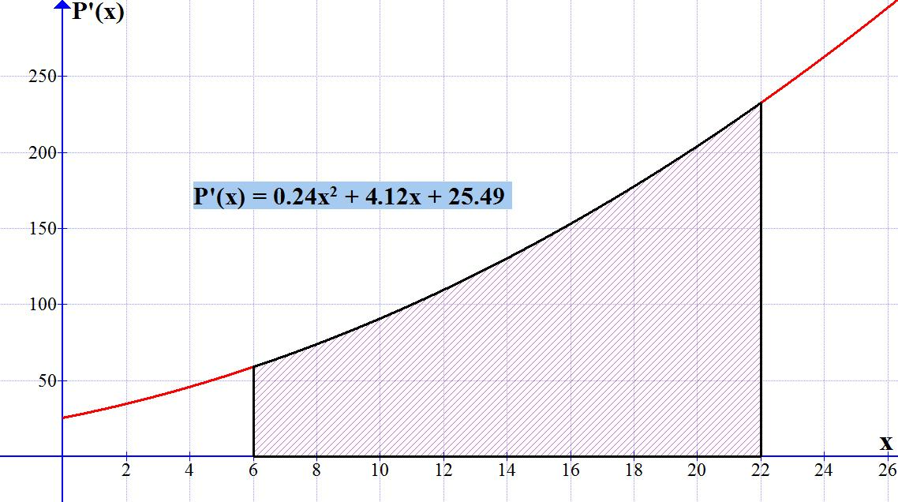

- Calculate the area of the shaded region. Show your work details.

- What information does the area give in terms of number of Internet users in this scenario? Would you estimate that this is a reasonable growth of Internet users from 2000 to 2016? Explain and justify your answer with critical thinking.

Unit 5 IP Assignment Choice 2:
According to its Web site, “SpeedOf.Me is an HTML5 Internet speed test. The smartest and most accurate online bandwidth test; it works well on…mobile devices as well as desktop computers.” By using your browser to test the Internet connection, it returns download and upload speeds including maximum rates and latency time periods. “It reflects your actual browsing and download experience.”
Be sure to show your work details for all calculations and explain in detail how the answers were determined for critical thinking questions. Round all value answers to three decimals.
- Go to this Web site, “stop all Internet activities, and click ‘Start Test’.” In the following order, record your device’s download, upload, latency, max download, and max upload values. Click “Share” and select the bottom right URL to copy and paste here below or copy and paste your Speedof.me graph below.

- Below is an example of download Megabits per second (Mbps):
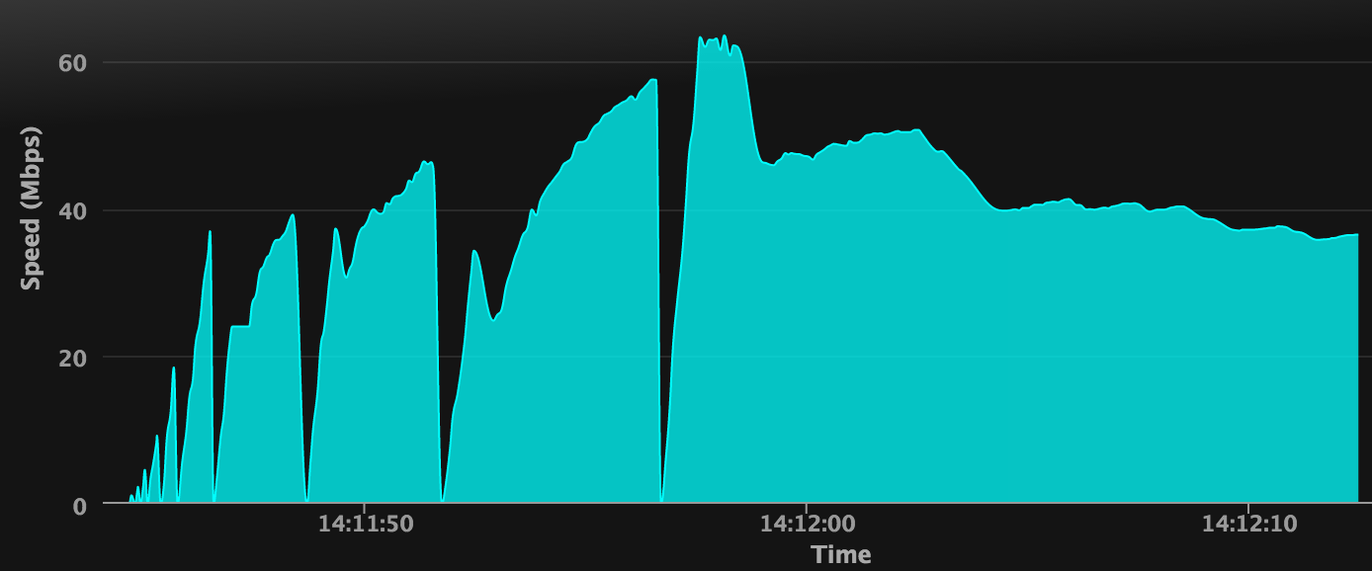
Note, that the diagnostics give the graph repetitive spikes as for example:
Let’s examine the first second of this activity, modeled by the polynomial function:
$$s\left(t\right)=20.25t^{3}-36.39t^{2}+19.46t$$
Here, s(t) is the download speed Mbps with respect to t in seconds with the domain of [0,1].
Generate a graph of this function $s\left(t\right)$ using Excel or another graphing utility. (There are free downloadable programs like Graph 4.4.2 or Mathematics 4.0; or, there are also online utilities such as this site and many others.) NOTE: Use axes scales -0.5 < x < 1.5 and -1 < y < 5. Insert both the function and the graph into the Word document containing your answers and work details. Be sure to label and number the axes appropriately.

- Evaluate: $S\left(t\right)= \int{\left(20.25t^{3}-36.39t^{2}+19.46t \right)dt}$. Be sure to show the work details and include the constant of integration, $C$.

- Based on the first letter of your last name, calculate the value of C from #3 by choosing an ordered pair (t, S(t)) from the table below.
First letter of your last name | t (seconds) | S(t) (in megabits)
A–B | 6 | 361
C–D | 7 | 513
E–F | 8 | 587
G–H | 9 | 719
I–J | 10 | 817
K–L | 11 | 1,018
M–N | 12 | 1,093
O–P | 13 | 1,319
Q–R | 14 | 1,574
S–T | 15 | 1,802
U–V | 16 | 2,267
W–X | 17 | 2,497
Y–Z | 18 | 2,802

- Evaluate the definite integral of this function over the interval [0,1]. Be sure to show the intermediate work details.

- In terms of this scenario what is the meaning of the definite integral calculated in question #5. Make sure to include your unit label measurements. Does this result seem reasonable? Explain and justify your answer with critical thinking.

References
Desmos. (n.d.). Retrieved from https://www.desmos.com/
Graph 4.4.2. (n.d.). Retrieved from the Graph Web site: http://www.padowan.dk/
Internet World Stats. (2015). Internet growth statistics. Retrieved from http://www.internetworldstats.com/emarketing.htm
Mathematics 4.0. (n.d.). Retrieved from the Microsoft Web site: http://microsoft-mathematics.en.uptodown.com/
SpeedOfMe. (n.d.). Retrieved from http:www.speedof.me/
WolframAlpha. (n.d.). Retrieved from http://www.wolframalpha.com/

