Name:
Date:
Instructor:
Course:

This worksheet is scored on a “point system”: each question lists the total possible points for a correct answer. The entire worksheet is worth 100 points
Section 1: Plate Tectonics
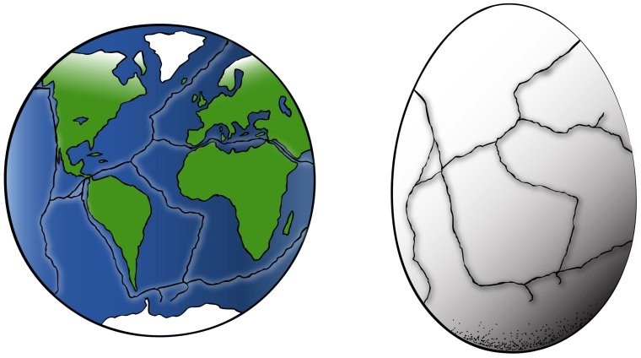
- How many “plates” do you notice (easier to count on the egg)? (5 points)

- How many landmasses do you see present? (5 points)

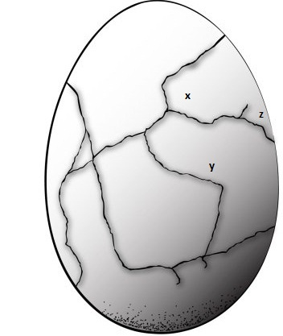

- Are X and Y on the same plate? (5 points)

- Are Y & Z on the same plate? (5 points)

- Are X & Z on the same plate? (5 points)

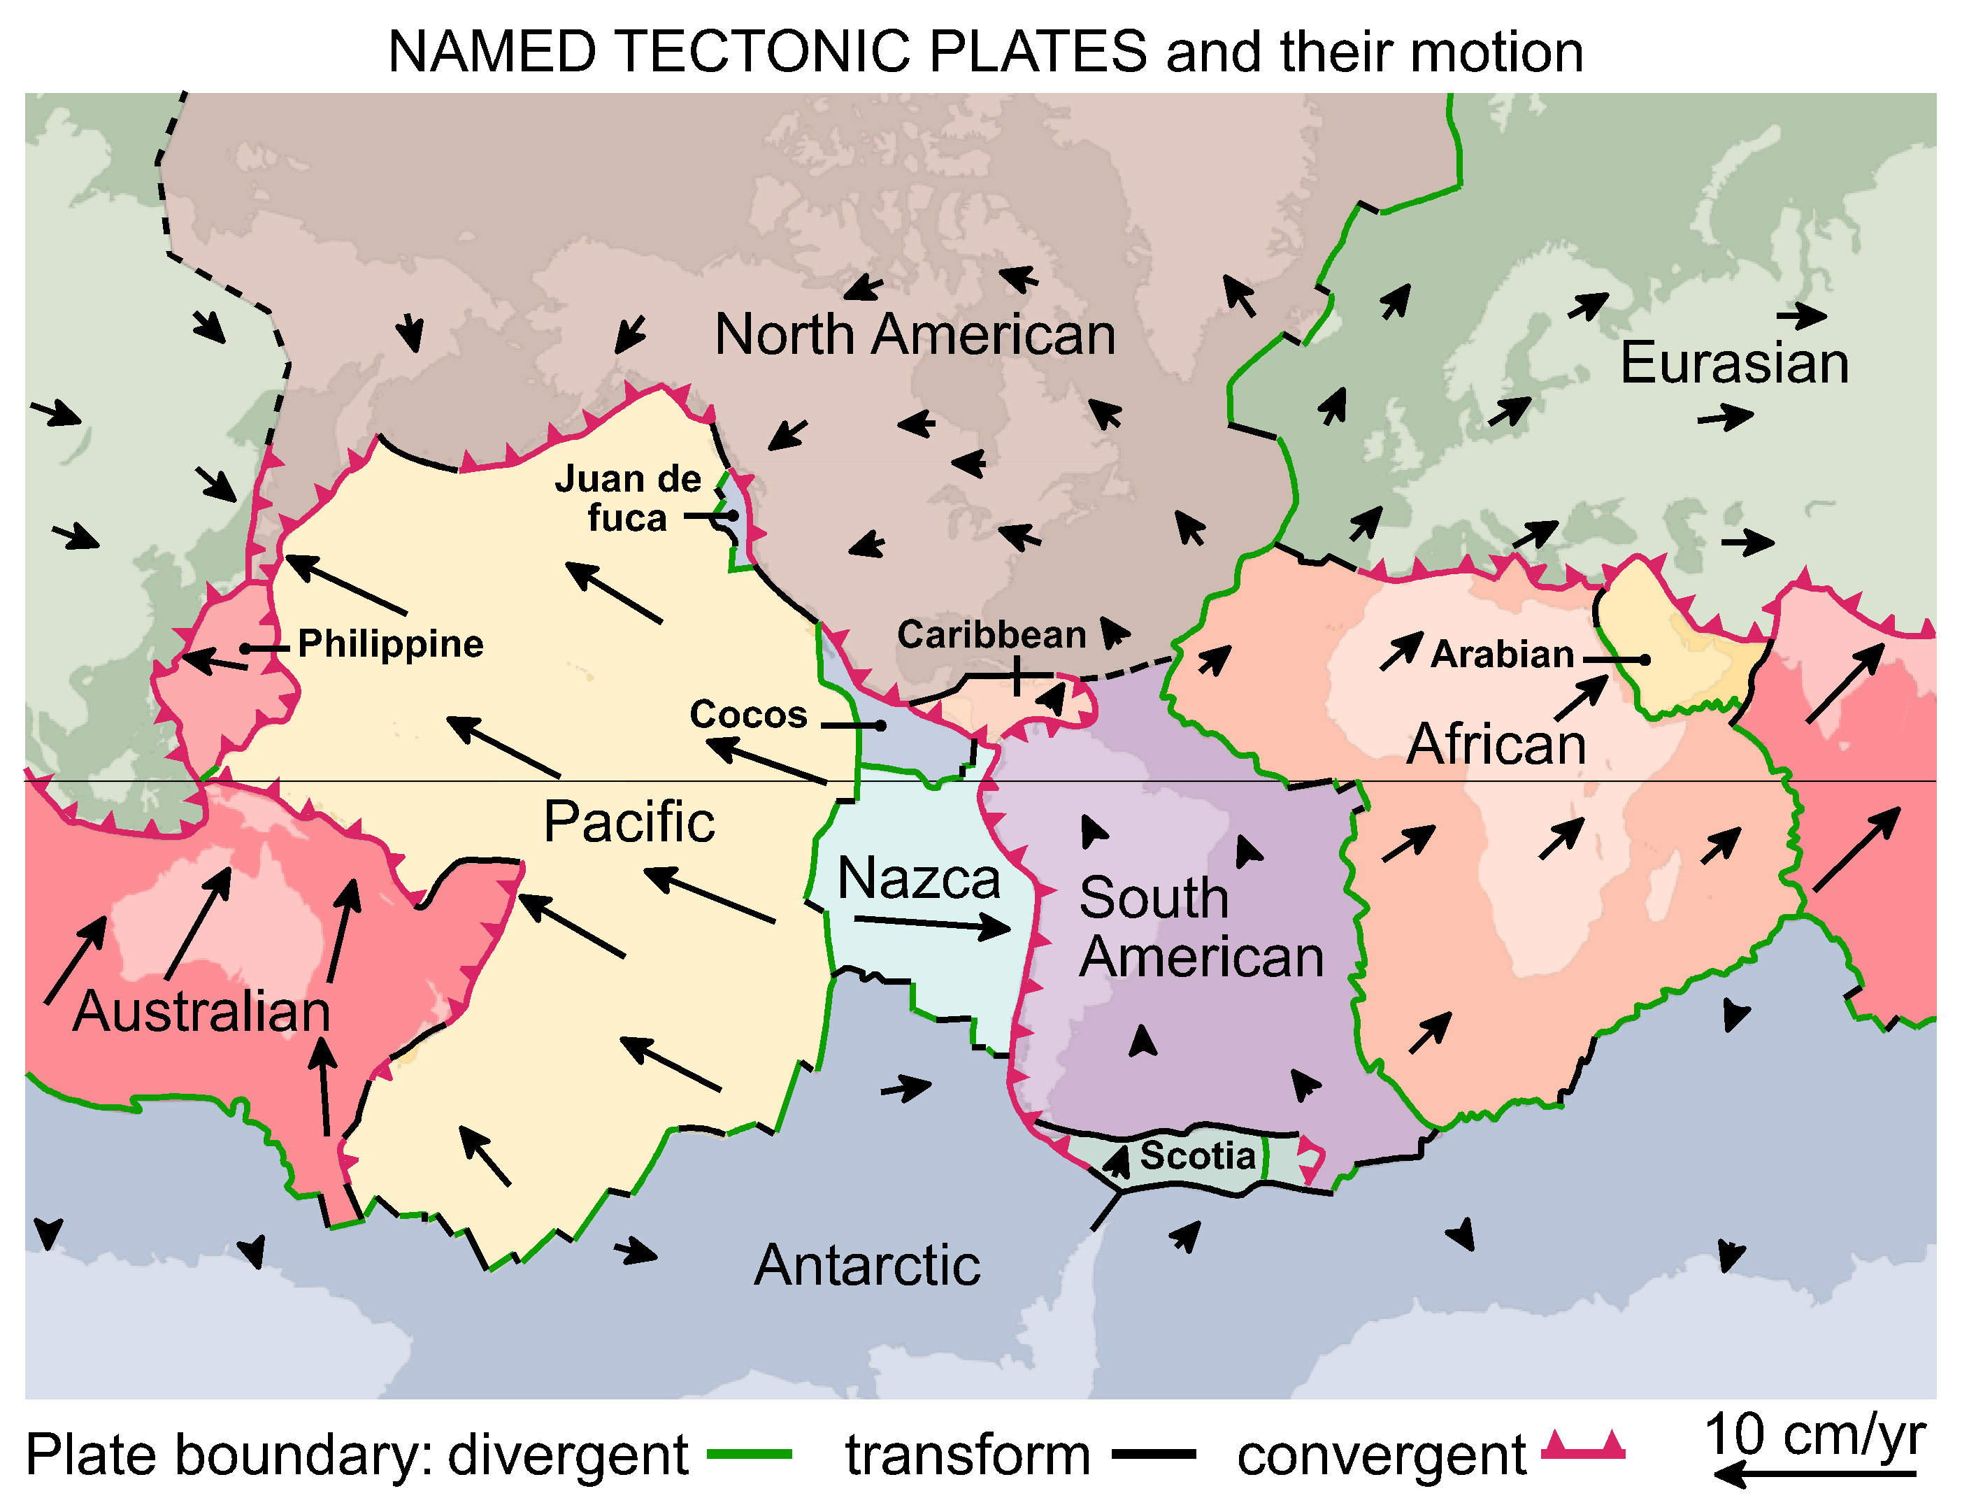
- Complete the table below based on the map shown above. (5 points total for the table)
Plates | Type of Boundary
North American Plate and the Pacific plate
North American Plate and the Caribbean plate
North American Plate and the Juan de Fuca plate
Australian Plate and the Eurasian Plate
Nazca Plate and South American Plate

- Describe what happens at each type of boundary. Must have two complete sentences for each boundary. You will use your textbook for this question. (5 points for each plate boundary: 15 points total)
  - Divergent
b. Convergent
c. Transform

- Study the direction the plates are all moving. What do you think this map will look like in another 50 million years, how do you think the location of the continents will have changed? Response should be at least 2 – 3 sentences. (5 points total)

Section 2: Volcanoes

While having a volcano nearby would be a great field trip, most teachers do not have this luxury. However, we do have numerous resources at our fingertips…literally.

Go to the following site:
https://www.cosmeo.com/braingames/virutal_volcano/index.cfm?title=Virtual%20Volcano

Explore the Global Perspective section, clicking on the different topics in the lower right hand corner.

Click on Types of Volcanoes and explore each one (see lower right hand corner).

Now click on the Build Your Own Volcano. Read the information provided.

Using the scales on the left of the webpage, create your own volcano. Experiment by changing the viscosity and the amount of gas. Click on the set criteria and then create eruption. Make sure you watch the entire animation. The following questions can only be answered by adjusting the amount of viscosity and gas and watching the various eruptions. You can click on change settings to create different eruptions.
9. Which volcanoes are considered the largest? (5 points)

10. Which volcano is the most eruptive/explosive? (5 points)

11. Describe each type of volcano, with 2 to 3 sentences, and give an example. You will use your textbook for this question. (5 points for each volcano type: 15 points total)

a. Stratovolcano:
b. Cinder Cone:
c. Shield:

Section 3: Earthquakes

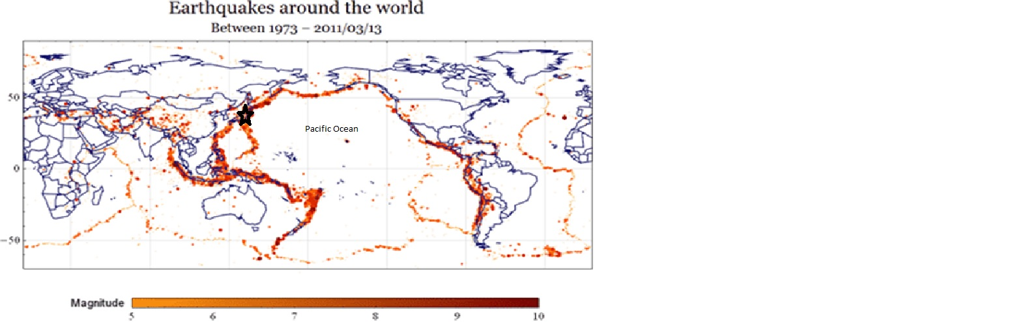
Atlantic Ocean
Indian Ocean
Arctic Ocean
Southern Ocean
- Do earthquakes occur around the coastlines of all oceans? (2 points)

- If you responded no, give an example of an ocean with no earthquakes around the edges. (3 points)

- Do earthquakes occur only along coastlines? (2 points)

- If you responded no, give an example of an area where earthquakes occur in the middle of an ocean and in the middle of a continent. (3 points)

- Do earthquakes occur only in one particular climate, such as where it is hot? (2 points)

- If you responded no, give an example of an area where earthquakes occur in hot climate and a cold climate. (3 points)

- Compare the Named Plate Tectonics map in Section 1 and the Earthquake Map in Section 3. Based on these, why do earthquakes occur where they do? Response must be at least one complete sentence. (5 points)

- Find Japan on the Earthquake map (labeled with a black star). Explain why Japan has so many earthquakes. Response must be at least two complete sentences. (5 points)

