intffaf



**creating an**



**ELEVATOR PITCH**



**Your Answers**

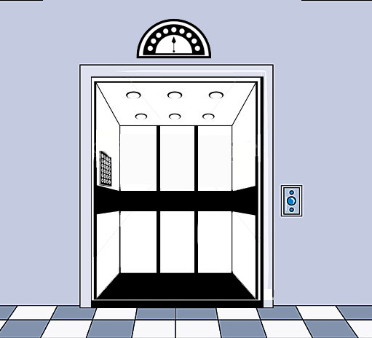

**Who are you?**

*EX:* I am an office support specialist.

**What are your skills?**

* Create a list of skills that you have.
* Separate relevant skills from the soft skills.
* Describe how each relates to the position or field you are seeking.

*EX:* With 10 years of experience in document production, desktop publishing, editing, and graphics, I am a creative individual with exceptional communication skills.



**What is your experience?**

* List what your experience is.
* Where did you gain this experience?

*EX*: I am a recent graduate with my degree in (or I am currently studying) Business Administration. I have previously worked in office support with Siemens and Canon where I focused on creating visual presentations to give to potential clients.



**What are your accomplishments?**

* List what your accomplishments are.
* How did it help the company you were working for?

*EX:* At the conclusion of a recent sales presentation, the customer mentioned that one reason for selecting our firm for the project was the clear message the presentation I developed delivered.



**What is your unique strength?**

* What makes you stand out?
* Why should somebody hire you?

*EX:* I specialize in working in high-pressure environments where attention to detail, quick development, and professional appearance are required for all documents. I am committed to an exceptional finished product.

**What are you looking for?**

* Try to avoid specific job titles.
* Focus on what you can do.

*EX:* I am looking to transition into an executive-level assistant role where I could utilize my client retention, organization, scheduling, and production skills.





**Ask for Help.**

**Thank the employer for listening.**



**Your Answers**

*Put it all together:* I am an office support specialist with 10 years of experience in document production, desktop publishing, editing, and graphics. I am a creative individual with exceptional communication skills, and I am a recent graduate with a degree in Business Administration. Previously, I have worked in office support with Siemens and Canon, where I focused on creating visual presentations to give to potential clients. At the conclusion of a recent sales presentation, the customer mentioned that one reason for selecting the firm for the project was the clear message that the presentation that I developed delivered. I specialize in working in high-pressure environments where attention to detail, quick development, and professional appearance are required for all documents. I am committed to an exceptional finished product. I am looking to transition into an executive-level assistant role where I could utilize my client retention, organization, scheduling, and production skills.