Personalized Learning Pathways
STUDENT FREQUENTLY ASKED QUESTIONS (F.A.Q.s)

- How do I begin the Personalized Learning Pathway System?
Log in into Virtual Campus and navigate to the classroom tab, where the Intellipath icon is displayed. The icon appears on the left-hand navigation under the Course Work category. A Intellipath icon is also displayed on the top notification bar within the Classroom tab, but only for the first 10 days after the start.

- What is the difference between Start, Continue, and Revise in the Personalized Learning Pathways System?
Start Intellipath is used at the beginning of a unit when you are starting your unit work and creating your unit Learning Map. The Continue Intellipath icon is displayed when you return to Personalized Learning Pathways to continue working on a learning node. The system takes you back to where you stopped working previously in the system. The Revise Intellipath icon allows you to revise and improve previously completed nodes.
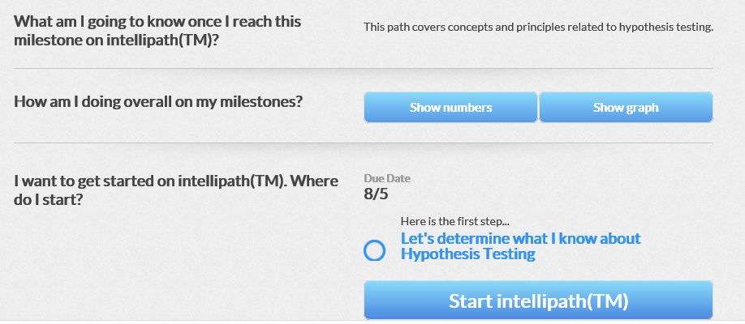

- What is Determine Knowledge?
Determine Knowledge is made up of some required beginning questions that you complete at the beginning of the unit, which allow the system to determine how familiar you are with the unit topics. The questions answered generate a Learning Map that shows your current knowledge state. Each unit will begin with a Determine Knowledge assessment. Click on Determine Knowledge from the Steps tab to begin.
- How do I interpret my Learning Map?
Use the Learning Map legend to determine your Percentage of Knowledge state, along with your Steps tab to direct you with your work. You may revise your nodes an unlimited amount of times prior to the assignment due date to improve your score. The bottom part of the legend indicates which knowledge is completed by the system and which knowledge you demonstrated as assumed by the system. It also indicates which learning nodes are recommended for you and which learning nodes are available for you to work on. The Locked symbol indicates learning nodes that need you to do more prerequisite work on the left-hand side of the Learning Map before recommending success for the locked node. Once the prerequisite work is complete, the learning node will unlock.
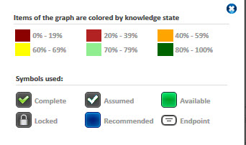
- Do I need to log in or have an access code to enter the Personalized Learning Pathways System?

No; once you are in your course, click the Intellipath icon from the left navigation bar in the Course Work section.

- How do I know what to work on next?
From the Guidance panel Steps tab, the next recommended steps are numbered for you.
- Where can I find the assignment due date?
The assignment due date is displayed on the Steps, Progress, and Advanced tabs.
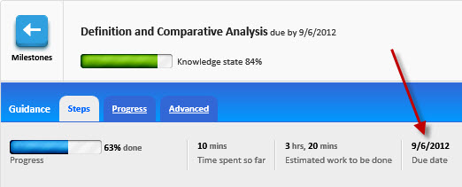
- How do I contact my instructor if I need assistance?
Click the “Send Message” icon at the top right-hand corner of the screen. This will open a message box that will allow you to type a message, and then click Send Message. 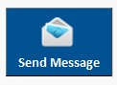

- Can I upload or attach a document/file in the Personalized Learning Pathways System?
No; this is not required in the Personalized Learning Pathways System.
- Can I post a response in the Personalized Learning Pathways System?
No; this is not required in the Personalized Learning Pathways System.
- Can I send messages to fellow students using the Personalized Learning Pathways System?
Not at this time, but a student can send messages to the instructor.
- Can I use Delete in the Personalized Learning Pathways System?
No; you will not be able to use the Delete function in Personalized Learning Pathways System.
- Can I download any content from the Personalized Learning Pathways System?
No; there is no reason to download content from the Personalized Learning Pathways System.
- Can I print content from the Personalized Learning Pathways System?
No; there is no reason to print content from the Personalized Learning Pathways System.
- Do I submit my assignment using the Personalized Learning Pathways System?
No; this is not required in Personalized Learning Pathways. Your assignment Learning Path work is automatically saved, and your instructor can review your work within the system.
- Why are some of my learning nodes locked?
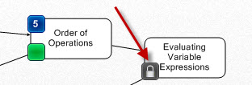
This is an indication that you need to work through learning nodes on the left-hand side of the map or the prerequisite nodes to unlock the white locked nodes on the right-hand side of the Learning Map.

- How do I access the page with all of my learning objectives and milestones?
Click the Milestones icon on the top left-hand side of the screen. This will take you to the landing page and will also allow you to select a different objective to learn.
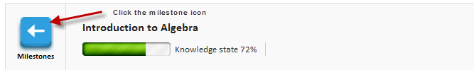
- Is there a calculator in the Personalized Learning Pathways System for my Math work?
Within a Lesson or Practice, after you have chosen the Learn, Revise, or Practice button, you will see a Calculator icon in the top right-hand corner. Click on the Calculator icon on the top menu.
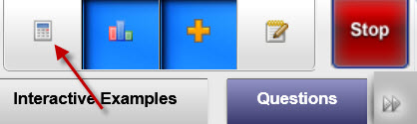
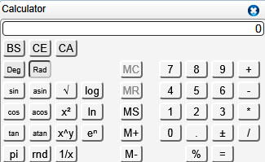
- Is there a Math Editor in the Personalized Learning Pathways System?
Within a Lesson or Practice, after you have chosen the Learn, Revise, or Practice button, you will see a Work Area icon in the top right-hand corner. Click on the Work Area icon on the top menu.
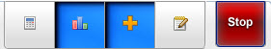
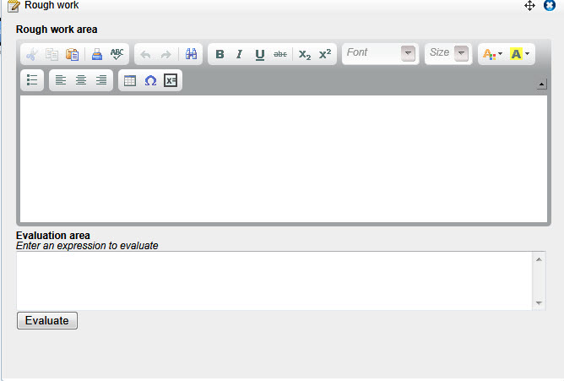
- Does the system save my work?
Yes; the system saves all of your work automatically as you work through the lessons. You will not have to save within the Learning Pathways System.
- Do I earn “extra credit” for taking part in the Personalized Learning Pathways System?
Not at this time. Personalized Learning Pathways assessments are part of your course assignments and as such do not result in extra credit or points.
- How do I access or improve a completed learning node?
Click the Revise button from the Steps tab, or you can click on a completed node within the learning map, and then choose “Revise.” 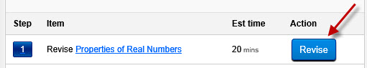
- Where are my grades?
Your Personalized Learning Pathways grades will be in your course grade book. Your grades will be available after the assignment due date. Also, check your Progress tab frequently to monitor your progress.
- How do I return to my course?
Close the browser window (X) in the top right-hand corner of your screen, and the system brings you back to your course. Once you are in your course, click the Intellipath icon from the left navigation bar in the Course Work section.

