Intellipath™ Student Tips

How does the Learning Map work?
The lessons are connected throughout the entire course map. Work on one lesson influences learning on other lessons in the course map. Learning is a continuum throughout the course, assessment is constant, and by revising lessons, you can continually improve their learning.
Main Goal
The main goal of the learning map is to prepare you for the course outcomes. For example, in the English Composition courses, the goal is to complete the Learning Map to improve writing which occurs on the assigned papers due in the course.
How do I get Technical Help?
Contact support@aiuonline.edu or call 877.221.5800 Option 2
How do I get help with a question on my Learning Map?
Contact your instructor for content type questions.
Why is Determine Knowledge important?
Determine Knowledge is very important as it tells the Adaptive Learning system what you know and what you do not know. It sets the baseline for your learning in each unit and it creates your learning map from the results of your Determine Knowledge. Allow enough time to take the Determine Knowledge uninterrupted, and give it your best effort. Complete the Determine Knowledge early in the unit to allow enough work time on your Learning Map as the week progresses. The more you let the system you know, the more accurate your Learning Map and your unit work.

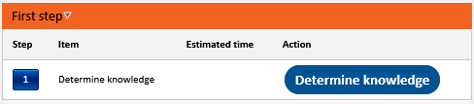

When is the Learn and Resume function used?
The Learn function is used when you first start a Lesson, found in the Next Steps section of your Steps tab, this is the beginning of a Lesson. Resume is for a Lesson you have worked on and now you want to resume your work.

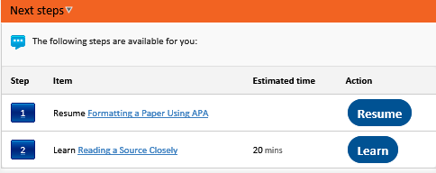
How do I complete a Lesson?
- Complete the Lesson sections
- Read the summary and choose Finish before leaving a lesson.
- Do not abandon lessons, choose the first or default option to save work when stopping an incomplete lesson.
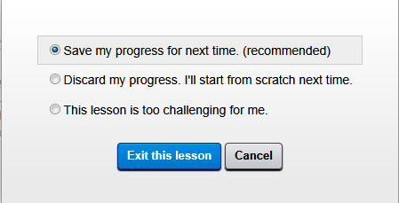

What are the differences and similarities between Revising a node vs. Practicing a node?
Revising and Practicing occur on lessons that have been worked on; they cannot be implemented on white, incomplete lessons.
They both count toward your score for Knowledge State and with success they should both change the color of the node chosen.
Revising lessons should be done after you have completed the unit lessons assigned.
- First, Click on Node to Revise
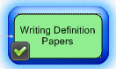

- Second, Choose Revise or Practice from Left Navigation
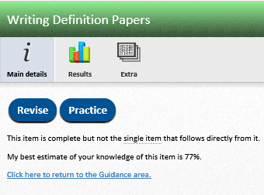
- Third, Complete Revise or Practice, and if successful, check out the change of color for this Learning node on your Learning Map
Practicing is either a student choice or directed as assigned by the instructor.
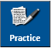

How does the light bulb work?
After you have answered a question, you can get more information and the solution by clicking on the light bulb. Choosing the light bulb does not change your answer. If you do this in the Worked Example or Interactive Example section, it should help you prepare for the Question Section of the Lesson.
