Week 5 Individual Project- Communicating Results and Recent Developments

Student Name
Colorado Technical University
ACCT350
Professor’s Name
Date

Introduction
When you start writing an academic essay, begin with an introduction. However, don't label it as "Introduction." Instead, use this part to give readers the background they need to understand your argument. Think about what information would help them. After that, transition smoothly into stating your main point, which is called the thesis statement. This usually comes at the end of the introduction and sums up what your essay will argue. Your thesis statement should also help guide readers through the rest of your essay.

Step 1
In this assignment, you will critique and analyze a visualization for efficient communication and results. Use Chapter 9 in your textbook and the visualization below to analyze overtime pay for the fire department. Address the challenges or issues that you see in the original data visualization below:
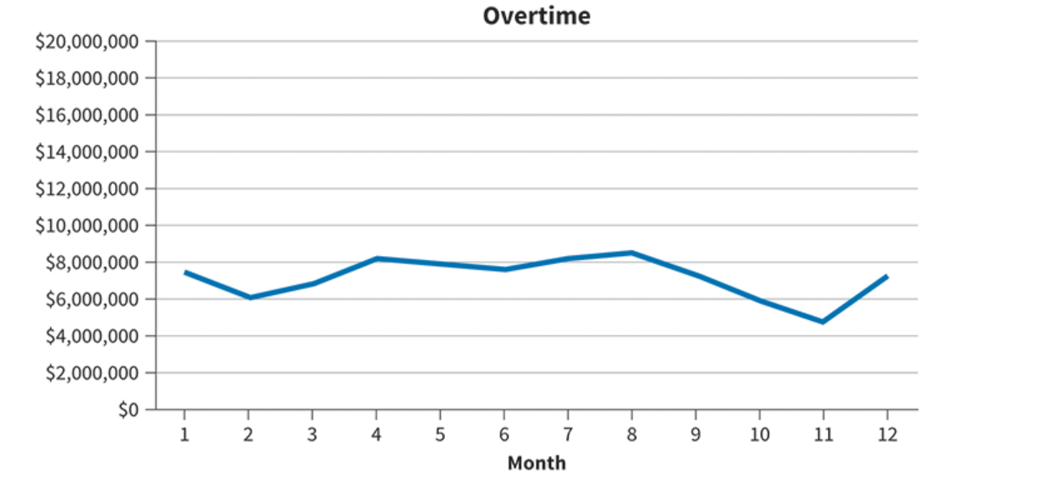
Using the overtime graph above, does it accurately present the data and provide effective communication of the results?
List the challenges and issues here:

Step 2
Create a new visualization using the data set from the overtime 2025 worksheet.
First you are going to add a column that changes the numbers to months.
- Add a column between month and amount in the overtime 2025 worksheet.
- Name the inserted column “Month’s Name” (in cell C1)
- Copy =TEXT(DATE(2024,B2,1),"MMM") formula in cell “C2”
- Put your cursor on the bottom right-hand corner of cell C2 until you see a plus sign (+).
- Double click on the sign. This will fill in the month’s names in Column C.
Now you are going to create a Pivot table
Highlight the data
- First highlight all the data titles (cells A1, B1, C1 and D1)
- Then hold the shift key and click end and the down arrow. You are going to select all three keys and then release them quickly. (This will highlight all of your data).
- Go to insert and click pivot table (You may have to select table and then pivot table.)
- Click existing worksheet and choose a cell in the same worksheet.
- Click ok.
- In the PivotTable Fields boxes that come up:
  - Select Month’s Name and make sure it appears under the Rows box or drag Month’s Name to the Rows box.
- Select Amount and make sure it appears under the Values box, or drag Amount to the values box.
You should now have a pivot table that shows the months and the amount from each month.
Put Pivot table here – taking a snip-it is the easiest way to copy the table.

Now it is time to create your visualization
- Click into the pivot table you created
- Click on insert
- Choose the line graph under charts as your visualization.
- Choose the first visualization under the 2D line category
- Drag the visualization chart to a place in the worksheet that does not cover your data.
- Click on the title of your visualization and change it to Fire Department Monthly overtime.
Side note: If your Sum of amounts have a range to $20,000,000, please change by doing the following:
    - Click on the x-axis
    - Right click format axis
    - Under bounds change minimum to “0” and maximum to 9,000,000.

Put line graph here – You can either copy and paste or take a snip-it

Step 3
Write an analysis that addresses the following questions:
- What short cuts did you find during the process of creating the pivot tables?
- What did you learn about communicating data results from completing this assignment? Think about the differences between the two charts and the way the data is organized.
- How should an organization use this visualization?

Conclusion
At the end of your paper, write a conclusion. If you're using headings, put a "Conclusion" heading there. In this part, sum up the main points of your argument. You can do this by giving more details about your main idea or going over the steps you took to make your argument. Also, remind the reader of the big parts of your paper and the important evidence you talked about. However, don't add any new information because that might confuse the reader. To finish your paper, think about what you want the reader to do with what they've read. You could suggest what they can do next to learn more about the topic. In the conclusion, explain why your work is important, and encourage others to build on it. Try to inspire the reader to think about new ideas or come to their own conclusions.
References
Cite sources alphabetically in APA format. Here are some examples of references cited in APA format: Examples below
Kieso, D. E., Wegandt, J. J., & Warfield, T. (n.d.). Intermediate accounting (18th ed.): Course resources. WileyPLUS. https://education.wiley.com/ng-course-dashboard/index.html#/instructor-resources
Khan, M. A., Ismail, F. B., Altaf, H., & Basheer, A. (2020). The interplay of leadership styles, innovative work behavior, organizational culture, and organizational citizenship behavior. Sage Open, 10(1). http://dx.doi.org.proxy.cecybrary.com/10.1177/2158244019898264
Kmec, J. (2012, March 13). Where’s the boss? And what counts as “work”? The Society Pages. https://thesocietypages.org/socimages/2012/03/13/wheres-the-boss-and-what-counts-as-work/

