Software Installation:
You are working as a mobile app developer and your goal is to start setting up an environment for the android app development. You first will need to install all the required components to develop the app on the Android platform. To start the development of the app in Android, you will need following components:
- Java Development Kit
- Java Runtime
- Android Studio
To download these items, follow these steps:
- Visit Oracle website and download Java Development Kit. http://www.oracle.com/technetwork/java/javase/downloads/index.html
- Visit the Java website to download the Java Runtime Environment. https://java.com/en/download/
- Review the system requirements for Android studio installation (as seen in image below).
- Visit https://developer.android.com/studio/index.html and install Android studio in your computer.
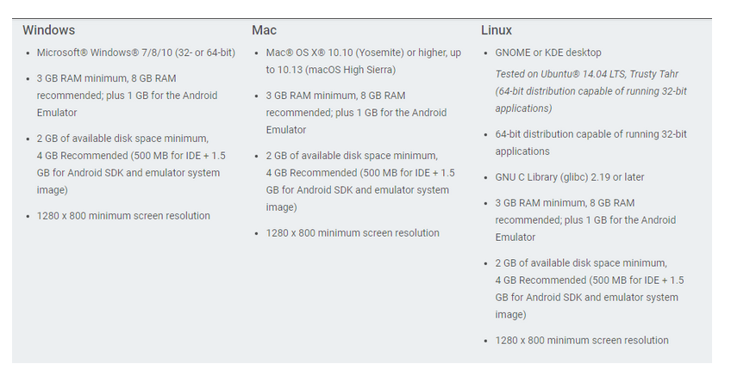
Image source: https://developer.android.com/studio/index.html

