Key Assignment
During the course, the combined week’s assignments will be your final Key Assignment deliverable, as depicted in the following flow diagram:
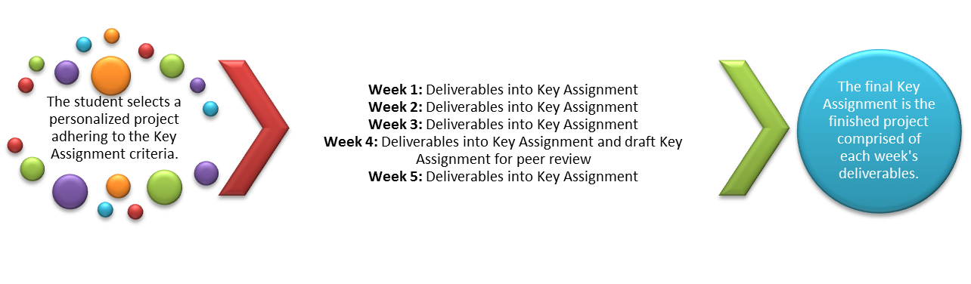
Throughout this course, you will be working with a scenario in which some basic background information is provided about a company. This information could apply to any company that provides customer services in general. Your goal is to select a small-to-medium-sized company of your choice, making sure that it is in an industry with which you are familiar or perhaps want to know more about. Each assignment that you complete in this course will be based on your selected company, using the scenario company as an example or model. You may us any additional information that you discover during your exploration and problem-solving process. Be sure to refer back to the Individual Project in Unit 1 as you progress through the problem-based learning (PBL) process. You may also want to print the outline that is provided in the Unit 1 Individual Project as a guide for you to follow throughout the course.
Problem-Based Learning Scenario
U.S. Sports Fanatics, LLC is a company that has been going strong, and demand for its popular goods among the sports-hungry fans is high. It has existed for 16 years. After reviewing proper data and statistics, the company needs to address issues in its response for better future requirements of the business. When the chief executive officer (CEO) noticed that something had to be done to accommodate the progressive growth of sales and increased customer base, locally and out of state, he and the rest of the management team decided to instill confidence by transforming their current enterprise system architecture (ESA) and information technology (IT) infrastructure to a better venue. Revamping of the IT infrastructure is an important need, and it will help with the transition from a mediocre IT infrastructure to the very latest state-of-the-art information technology platform.
Of course, any organization would love the top-of-the-line technology, but this all depends on the budget of U.S. Sports Fanatics. The gist of the upgrade that is needed is based on the fact that growth of the business has quadrupled. The gains and income have ballooned to new heights. Initial funding is not a problem, but maintaining the investment is the issue of the needed remodeling of the enterprise system architecture and IT infrastructure.
The chief information officer (CIO) has convinced the CEO to also expand their existence online and to be an e-commerce and e-business effective immediately. Both the CEO and CIO have decided on the expansion of the business and have made plans to move to a new building and require major upgrades in the facilities and information technology infrastructure.
Because of the popularity of the product that the store has, management decided to expand their inventory and implement a good database system and install methodology to transform the operating model to another type. Both the CEO and CIO are in complete agreement on the difficult and demanding task that lies ahead of them.
Currently, the enterprise system architecture and IT infrastructure have been bypassed as a stagnant and ineffective method of practice of business. Also, more policies and guidelines must be established with the way privileges are given to staff and managers to access available data. U.S. Sports Fanatics has to restructure its line of business to accommodate the excessive overhead caused by the lack of proper business venture that it runs. The human resources (HR) department has had a multitude of issues running their regular business with their staff because of a very outdated systems and impractical database use. As a consulting team of information technology and enterprise system architecture, you have to help U.S. Sports Fanatics reach its goal and implement all of its important needs. The time frame and deadline of effective renovations of the business IT infrastructure and enterprise systems architecture is mounting a complex challenge to you and to U.S. Sports Fanatics. It needs help in upgrading the following:
- Evaluate the current enterprise system architecture and IT infrastructure for U.S. Sports Fanatics, LLC
- Develop a course of action based on the resources that enterprise system architecture and IT infrastructure are supported and used at U.S. Sports Fanatics, LLC
- Design the course of action and apply the solution with extreme caution and specificity
- Implement the solutions, and make sure you run the two systems in parallel until the transitioning is a smooth process
- Debrief and assess the implementation of the solution with an eye towards the future requirements of U.S. Sports Fanatics, LLC
- Maintain the current and future status quo of transactions with a superb analysis of sales, backup, purchasing, budgeting, payroll, HR, and databases
- Delegate authority to U.S. Sports Fanatics, LLC staff to fully cooperate with the consultant to reach a solution to the massive changes in U.S. Sports Fanatics, LLC
- Analyze and compare the progression of the upgrade and expansion process very closely, and keep monitoring the status as the process is being installed to the U.S. Sports Fanatics, LLC's main source of business
The company knows and believes that such successful acquisition of a solution will be beneficial for the longevity of the company, and it allows it to match all demands of all traits. Using a seasoned consultant can remedy the instantaneous need for major upgrade of U.S. Sports Fanatics.
Strengths, Weaknesses, Opportunities, Threats
The following is a brief description of the strengths and weakness of the company.
- Strengths: Processes orders in a timely manner and has a good reputation in providing high-quality work
- Weaknesses: Not a very big company
- Opportunities: Can be upgraded to open multiple franchises
- Threats: Online ordering has big competition, and an upgrade of the IT infrastructure will be needed facilitate online orders
Problem-Based Learning Perspectives
- Rod, CEO: “The sales are constantly increasing, and we have no structured methodology that allows us to keep track of everything that is being sold. We have grown a lot, and we need a systematic way of matching our growth. We also need a better HR system as we hire new employees with our company in constant growth. The sales data and the general ledger need to be organized in a database that can be queried quickly, and I worry about response time. Customer satisfaction is a key issue.”
- Hannah, CIO: “We have to overhaul our entire enterprise system architecture by updating our operating model. We currently have a replication model, and we need to switch to a better model where integration and standardization mode have to be updated. The IT infrastructure has to be updated to match our performance and constant customer demands. We are getting bigger, but our entire management of information is very shaky and inept.”
- Jacob, IT Manager: “I have been around many organizations that use IT in a very incapable way. I rate our IT presence and performance as very limited because of the old and subpar resources and the IT infrastructure that we have. I really appeal to management to implement and install a new enterprise system architecture and a better IT infrastructure. This will only increase customer satisfaction and increase our customer base. We have grown so fast that we are unable to keep tabs on every essence of our business transactions including sales, returns, purchases, budgets, and payroll. Most importantly, we need a database that makes our job quick and easy to navigate records of sales and inventory. We need to install a point-of-sale (POS) system that has to be effective with our inventory. There is also a daunting task of safeguarding the company data for natural disasters such as flooding, earthquakes, hurricanes, and so forth.”
- Jackie, Sales Manager: “I have been with the company for a period of 6 years and have witnessed a very arduous task in keeping up with sales records and databases. There has to be a successful solution to data retrieval and data backup. We have to follow the CIA rule (confidentiality, integrity, and availability). Database backup on-site and off-site has to be implemented by reducing data redundancy and filtering the data to make them well-kept and backed up as well as maintaining their integrity.”
- Christine, Customer Representative: “I believe as it is well-known that the customer is always right and they are always a ‘King.’ So it has been a very hard and demanding year. With the skyrocketing growth of our organization, I am having a rough time successfully tending to our customer base because of the lack of the IT infrastructure and enterprise system architecture implementation. There has to be very unique and constructive methods that are installed through the right software that will enable me to handle the customer base and be very punctual and professional in my response to our customers. So there has to be a solution to this nagging problem. As you expand, so should your IT infrastructure.”

