Key Assignment
During the course, the combined week’s assignments will be your final Key Assignment deliverable, as depicted in the following flow diagram:
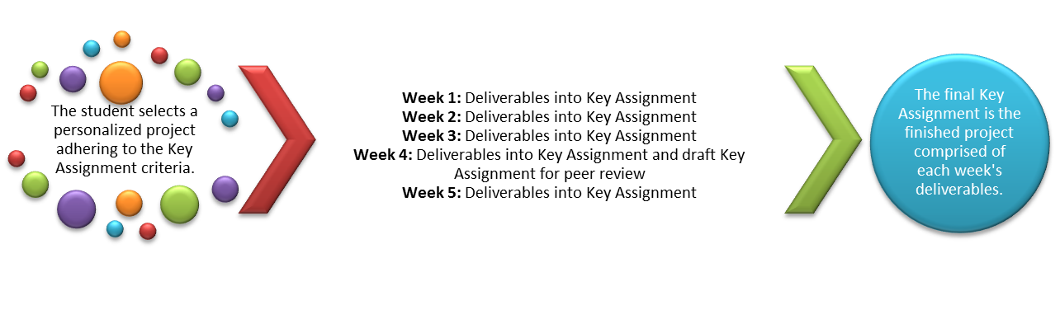
Throughout this course, you will be working with a scenario in which some basic background information is provided about a company. This information could apply to any company that provides client services (including healthcare) in general. Your goal is to select one of the companies in the assignment description (or create one of your choice), making sure that it is in an industry that you are familiar with or perhaps want to know more about. Each assignment that you complete in this course will be based on the company scenario that is provided and any additional information that you discover during your peer-review research and problem-solving process. Be sure to refer back to the Discussion Board in Unit 1 as you progress through the problem-based learning (PBL) process. You may also want to print the outline that is provided in the Unit 1 Discussion Board as a guide for you to follow throughout the course. The discussion boards are designed as a foundation to these assignments and can be used directly to start/augment your research.
Problem-Based Learning Scenario
Because of rapid growth of the business, internal processes, systems, and governance concerning the data necessary to work with clients have lagged behind. It is currently difficult to manage projects and the associated data. It is common for client representatives to misplace vital information, and clients are concerned about the security of their sensitive data because the consulting company has not been able to establish clear data management policies. Recently, data from two different clients was misplaced on an external Web site and published on a public forum. This incident caused a loss of business and impacted the company’s momentum in the market. Company management has determined that more formal methods of data management are necessary, but the company lacks the resources and expertise to move forward with a proper enterprise content management (ECM) and data governance plan.
Because of the desire of management to establish more formal data management policies but also because of their lack of understanding of the scope of the problem, a weak effort was made 2 years ago to move in the right direction. The IT manager was tasked with a project to get the data management organized. The IT manager was not experienced in this area, and consequently, the project only resulted in identification of some data in a more organized fashion; however, no policies regarding management of the data were established, and the company still suffers from poor data management practices. The IT manager did learn a lot about enterprise content management during this lackluster project and learned enough to understand that the project would require a deeper understanding of EDM facts from a researcher. The company wants to understand the facts this time instead of guessing. What is the history of EDM, how should it work, and how could it interact with the company, company data, and company IT. Understanding implications of growth is also desired.
At this point, the company's chief executive officer (CEO) and chief information officer (CIO) are in agreement that a significant new project must be initiated to analyze the current data management systems and policies as well as to design and implement a comprehensive architecture to properly manage the company’s data.
- Evaluate the foundations of EDM and benefits.
- Develop a plan with company data, related IT, and how they interact with the EDM.
- Design a plan for updating the enterprise information infrastructure of the company.
- Evaluate the foundations of governance and the impact on policies and procedures of the company and how it interacts with EDM.
- Develop a plan to incorporate governance through the EDM policies and procedures for the company with growth in mind.
The company believes if these goals are met with the project, the company will be in a much stronger position to support the planned growth and protect the company and client data in the future.
Problem-Based Learning Perspectives
John, CEO: “The data in this company is a mess, and frankly, I’m embarrassed by the way we handle our information. We’re supposed to be the experts and we assure our clients that we know how to manage and protect their HR data, but we can’t even get our own house in order. Half of the time, I can’t even get information I need to run this business, so I feel like I’m flying blind. I know that if we could just get ahead of the curve with our data management, we could handle the growth we have planned for the business. I also want to be able to tell our clients that their data is secure without feeling like I’m misleading them with information from the Internet, not actual facts.”
Judy, CIO: “I’ve been around long enough to know what proper data management looks like, but I sure haven’t seen it here. It’s great to hire someone like me and establish a better IT group for this growing company, but just putting the people in place isn’t going to straighten out the mess that was there when I started my job 3 months ago. I have good people in my group, but there is so much work to do every day, we don’t have the time to even start on getting better data management policies and practices in place. I’ve been through this before though, and I know it’s time to get an expert in here and get the job done right. I think everyone is ready for progress in this area from facts and research that points us in the right direction.”
Ronald, IT Manager: “I can’t believe they actually thought I could do my job and also manage this big data management improvement project. I got lost in the details, and there was no support from anyone to get the help I needed. Well, at least I managed to get the databases reworked so we could get all this information more organized. Nobody seems any happier about it now than they were before though. If they would just decide what they want, I can get the systems put together. I’m just not a rocket scientist when it comes to all these new approaches to data management. I’ve heard the term 'enterprise content management and governance' kicked around, but as far as I’m concerned, those are just fancy names for better databases. I think I’ll just stick to my IT work and let someone else figure out the big picture.”
Lynn, Customer Service Representative: "This has been a tough couple of months. I’m the one that has to try to work with our clients when something goes wrong. I like to help and that’s why I’m in this position, but this job is not all that pleasant when the clients are calling about serious matters and they are not very happy. Twice in the last 2 months I have had to deal with clients who found some of their sensitive HR data published on public Web sites. I have no idea who accessed the data or how, but I can tell you the clients were not satisfied with me telling them I didn’t know. This isn’t my fault, but I’m sure trying to make sure someone in this company knows how upset the clients get when these things happen.”

