MGMT435
Unit 1 Assignment
Risk Assessment Chart Analysis
Your Name
American InterContinental University
Submission Date

Introduction
Delete highlighted information.
The introduction is the best opportunity to convince your audience that you have something worthwhile to say (one solid paragraph). An introduction can accomplish this by fulfilling five important responsibilities, as follows:
- Get the audience's attention.
- Introduce the topic.
- Explain its relevance to the audience.
- State a thesis or purpose.
- Outline the main points.

Risk Assessment
- Define risk assessment in a project plan.

Risk Assessment Importance
- Explain the importance of a risk assessment in a project plan.

Scenario
You are the project manager working on a Market Mailing project. The client informed your project team during the project planning phase that the project must be completed on time in order to sync with the launch of the new product. Also, the client informed you and the team that there is no cash reserve for the project so the project has to be completed within budget. Below is the status update that two project team members (Jennifer and Ben) put together. Based on the project’s performance to date, complete the Rating Project Risk exercise on the next page.

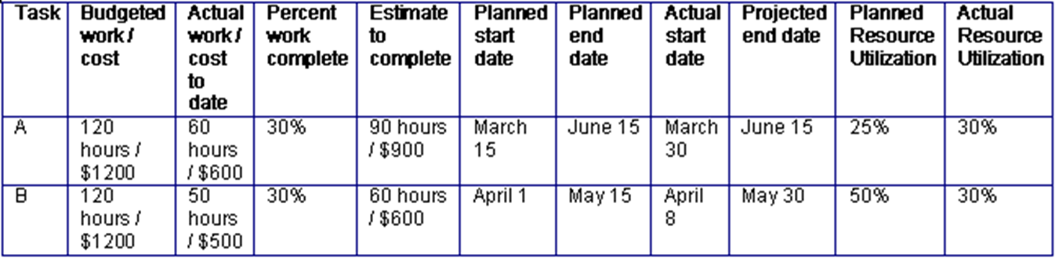

Rating Project Risk
Based on the project’s performance complete the risk assessment chart below by rating each risk factor as follows:
- High, medium, or low in terms of its potential impact
- High, medium, or low in terms of its probability of occurrence
Project Risk Items | Potential Impact  (H / M / L) | Probability of Occurrence  (H / M / L) | Overall Risk  (H / M / L) | Risk Score Justification Statement
Completing Task A over the $1,200 budget
Completing Task A after the scheduled end date of June 15
Completing Task B over the $1,200 budget
Completing Task B after the scheduled end date of May 30
Extract the combined effect of those two values, combined with your judgment, and score each risk factor as high, medium, or low overall. Justify your scores using the data provided above.

Conclusion
The conclusion is the last thing that the reader will remember about your essay.
- The conclusion should be a summary of the highlights of your statement of purpose.
- The conclusion should include the main points of the statement of purpose.
- The conclusion should be as well-constructed and grammatically correct as everything.

References
Example
Jayaraman, R. (2016). Project cost control: A new method to plan and control costs in large projects. Business Process Management Journal, 22(6), 1247–1268. https://doi.org/10.1108/BPMJ-10-2014-0102

