Critical Path Method
Your Name
American InterContinental University
Submission Date

Introduction
Delete highlighted information.
The introduction is the best opportunity to convince your audience that you have something worthwhile to say (one solid paragraph). An introduction can accomplish this by fulfilling five important responsibilities, as follows:
- Get the audience's attention.
- Introduce the topic.
- Explain its relevance to the audience.
- State a thesis or purpose.
- Outline the main points.

Critical Path Method
- Define the critical path method (CPM) in a project plan.

Critical Path Importance
- Explain the importance of a critical path in a project plan.

PERT Diagram
- Define a PERT diagram in a project plan.

- Explain the importance of a PERT diagram.

- Review the PERT diagram below, and discuss how you would find the critical path.

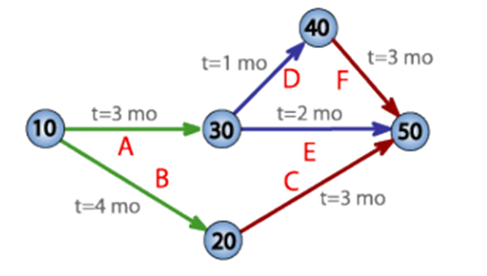

Restaurant Scenario
Marie, Darren, and Noah are standing at an intersection in Atlanta’s northwest corner. They decide to eat dinner at a restaurant in the southeast corner of the city, but each chooses to take a different path to travel across town, as follows:
- Marie takes a bus that zigzags across surface streets: She makes it to the restaurant in 24 minutes.
- Darren decides to take the subway that travels directly to the restaurant: He makes it to the restaurant in 14 minutes.
- Noah travels with a bicycle along a path and makes it to the restaurant in 19 minutes.
The three cannot eat dinner until the last person has reached the restaurant.

- Based on the scenario above and using the CPM, determine which person (Marie, Darren, or Noah) is on the critical path.

- Explain why you selected the person while including detailed information from the scenario.

Work Breakdown Structure (WBS)
- Define the WBS.

- Explain the importance of the WBS.

Gantt Chart
- Define what a Gantt chart is.

- Using the information in the Gantt Chart attachement, answer the following question.
  - Today is May 10th, what can you determine about the status of the project?

Conclusion
The conclusion is the last thing that the reader will remember about your essay.
- The conclusion should be a summary of the highlights of your statement of purpose.
- The conclusion should include the main points of the statement of purpose.
- The conclusion should be well-constructed and grammatically correct.

References
Example
Réveillac, J. (2017). Modeling and simulation of logistics flows 1: Theory and fundamentals (1st ed.). Wiley.

