Name:
Date:
Instructor:
SCI101 Nutrition Intake Worksheet

- Track what you eat for 1 full 24-hour period. You should write down every food item you eat and anything you drink that is not water. Visit the following Web site or use food packaging labels to fill out the nutritional information for your food: https://fdc.nal.usda.gov/.

Search for each food item you ate. As you determine the nutritional information, complete the table below. The “Fuji Apple, Raw” entry is an example. Delete it if you didn’t eat one!
Food Item | Energy (Calories) | Protein | Lipids (Fats) | Carbohydrates
Fuji Apple, Raw | 52 | 0.26 | 0.17 | 13.81

- Add up all of the nutrients you ate for the 24-hour period. Enter that information in this table:
Energy (Calories) | Protein | Lipids (Fats) | Carbohydrates

- Find your age, gender, and activity level in Table 1 below to determine your estimated total energy intake (calories), based on your level of activity. Use the following definitions to help you:
- Sedentary: A lifestyle that includes only the physical activity of independent living
- Moderately active: A lifestyle that includes physical activity equivalent to walking about 1.5–3 miles per day at 3–4 miles per hour, in addition to the activities of independent living
- Active: A lifestyle that includes physical activity equivalent to walking more than 3 miles per day at 3–4 miles per hour, in addition to the activities of independent living.
- Note for those who are pregnant or lactating: Based on the chart below, add the appropriate amount of calories to your estimated amount.
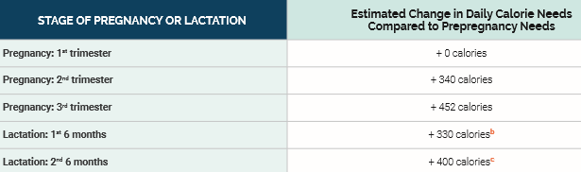
(USDA, 2020)
- Find your age and gender on Table 2 below to determine the recommended amounts of proteins, carbohydrates, and lipids (fats).
  - Enter your estimated/recommended amounts in this table:
Estimated Energy (Calories) | Recommended Protein (g) | Recommended Carbohydrates (g) | Recommended Total Lipids (fat) (% kcal)

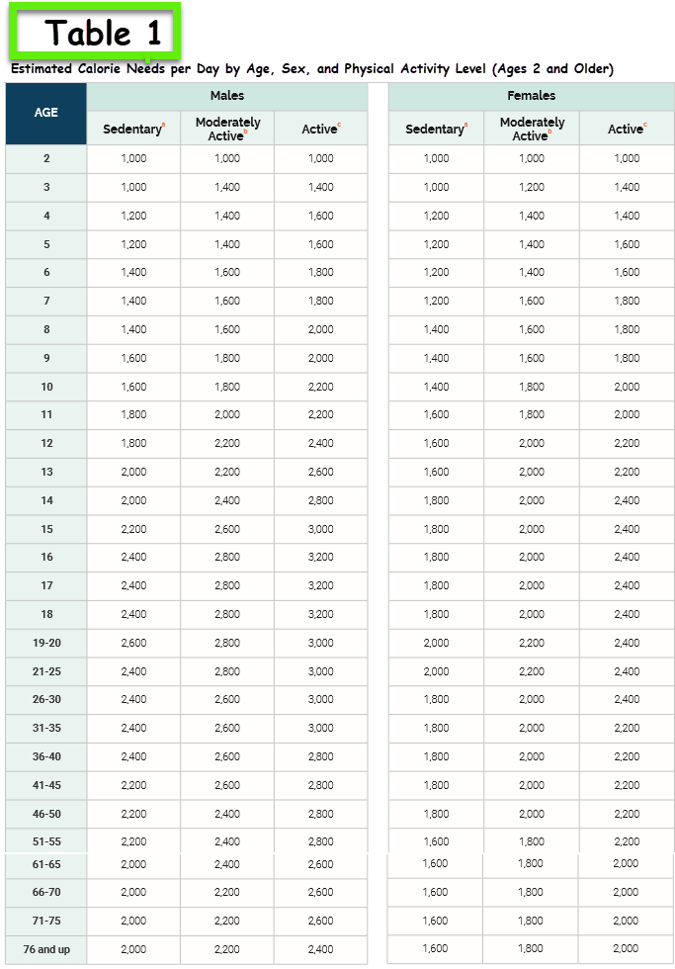
(Trumbo et al., 2003)

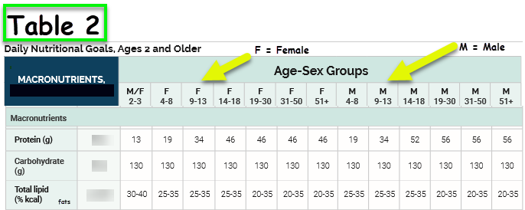
(Trumbo et al., 2003)
References
Trumbo, P., Schlicker, S., Yates, A. A., Poos, M. (2003, May). Dietary reference intakes for energy, carbohydrate, fiber, fat, fatty acids, cholesterol, protein, and amino acids. Journal of the American Dietetic Association, 103(5), 563.
U.S. Department of Agriculture (USDA). (n.d.). FoodData central. Retrieved from https://fdc.nal.usda.gov/
U.S. Department of Agriculture (USDA). (2020, December). Dietary guidelines for Americans, 2020-2025 (9th ed.). Retrieved from https://www.dietaryguidelines.gov/sites/default/files/2020-12/Dietary_Guidelines_for_Americans_2020-2025.pdf

