Name:

Date:

Instructor’s Name:

Assignment: SCI103 Unit 2 Individual Project (Lab Report)

Measuring pH Levels

Instructions: Enter the Virtual Lab, and conduct the lab tests. Please record your answers on this Lab Report form. When your Lab Report is complete, submit it to the Submissions area of the Virtual Classroom.

The pH Scale: https://youtu.be/Xkrgw2CFwRs

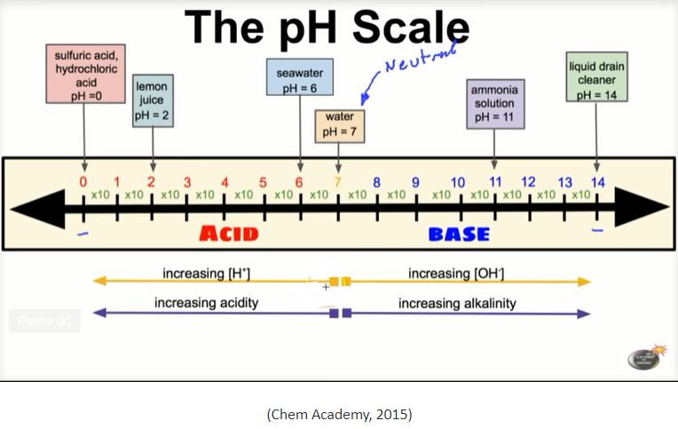

Part I - Lab Tests: Answer the following questions while in the virtual lab.

Section 1: You will test 4 known solutions for pH levels using a standard wide-range indicator. Based on the results obtained in the virtual lab, fill in the following table:

Solution Number | pH from Lab | Acid, Base, or Neutral? | Solution Name (What was in the test tube?)
Solution 1
Solution 2
Solution 3
Solution 4

Section 2: Now that you understand how to read pH measurements, follow the virtual lab to gather pH samples from 3 different lakes. Test these in the virtual lab, and answer the following questions:

- What was the pH level measured at Lake 1?

- What was the pH level measured at Lake 2?

- What was the pH level measured at Lake 3?
- Which two lakes have the highest levels of acidity in their water?

Part II – Your Examples: Use the templates below to guide your answers.

Look for at least 3 acids and at least 3 bases around your home. Remember that acids have a pH level lower than 7, pH 7 is neutral, and bases have a pH level higher than 7.

Three examples of acids that I found in my home are:
- ______________________
- ______________________
- ______________________

Describe each of the three acids using complete sentences. Some suggestions…what do they contain, what they are used for and why, what are their properties, what is their pH?

1.
2.
3.

Describe the common attributes of acids:

Three examples of bases that I found in my home are:
- ______________________
- ______________________
- ______________________

Describe each of the three bases using complete sentences. Some suggestions…what do they contain, what they are used for and why, what are their properties, what is their pH?

Describe the common attributes of bases:

Part III – Short Answers: Answer the following questions in short-answer format (3–5 detailed sentences each).

Look at your data for the three lakes in the virtual lab. Acid rain is impacting two of these three lakes. Answer the questions below to explain how the location of each lake relates to its pH level.

- What is acid rain?

- Which two lakes from the virtual lab are receiving acid rain?

- Discuss how the location of each lake (Lake 1, Lake 2, and Lake 3) relates to its pH level. Include some of the impacts of acid rain. Use data from Part 1, including what you observed on the signs for each lake, to justify your points.

- Imagine that a lake receives acid rain for an extended period of time. The original pH of the lake was 6, but it has now dropped to pH 3. How many times more acidic has this lake become? Watch this resource video for help: https://www.youtube.com/watch?v=Nf8cuvl62Vc

- What negative impacts can this amount of acidification have on the environment?

References
Chem Academy. (2015, April 28). The pH scale explained [Video file]. Retrieved from the YouTube Web site: https://www.youtube.com/watch?v=Xkrgw2CFwRs
FuseSchool – Global Education. (2014, August 10). Acid rain | Environmental chemistry | Chemistry | FuseSchool [Video file]. Retrieved from https://www.youtube.com/watch?v=Nf8cuvl62Vc

