[**Enhancing Law Enforcement Response to Victims**](https://www.theiacp.org/projects/enhancing-law-enforcement-response-to-victims-elerv)

This program seeks to—

* create community-wide trust and confidence in the police,
* foster the healing process for victims, and
* produce stronger, more comprehensive cases for law enforcement.

[Learn more about this OVC-sponsored program.](https://www.theiacp.org/projects/enhancing-law-enforcement-response-to-victims-elerv)

[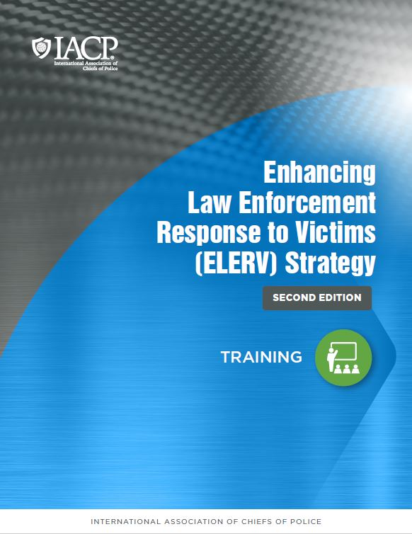](https://www.theiacp.org/sites/default/files/ELERV/0.%20Training-%20ELERV%20Foundational%20Document.pdf)

[**Training**](https://www.theiacp.org/sites/default/files/ELERV/0.%20Training-%20ELERV%20Foundational%20Document.pdf)

This document contains detailed information about the thought processes behind the ELERV Strategy as well as concrete implementation steps, tips and examples from the demonstration site teams, and links to tools, resources, and customizable templates.

[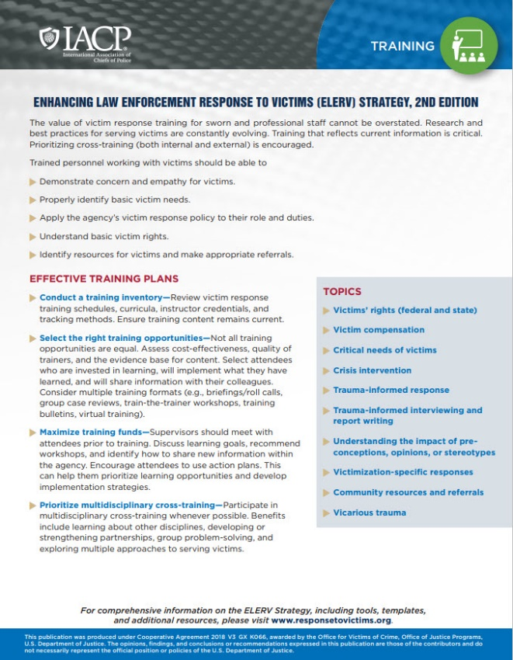](https://www.theiacp.org/sites/default/files/ELERV/4.%20Training%20Overview_508.pdf)

[**Training Overview**](https://www.theiacp.org/sites/default/files/ELERV/4.%20Training%20Overview_508.pdf)

This single-page document highlights important information from this section of the ELERV Strategy. The quick read format makes it perfect for roll-call training and meetings alike.

**Materials from Training**

*Samples*

* [Training Bulletin—Critical Needs of Victims](https://www.theiacp.org/sites/default/files/ELERV/1.%20Training%20Bulletin-%207%20Critical%20Needs.pdf) *(PDF)*

*Templates* - *These templates are intended to provide sample language and content. These templates should be customized to fit agency needs and should be carefully reviewed to ensure information is consistent with requirements within the agency and local jurisdiction.*

* [Crisis Intervention](https://www.theiacp.org/sites/default/files/ELERV/2.%20FINAL-%20Crisis%20Intervention.pptx) *(PowerPoint)*
* [Critical Needs of Victims](https://www.theiacp.org/sites/default/files/ELERV/3.%20FINAL-%20Critical%20Needs%20of%20Victims.pptx) *(PowerPoint)*
* [Effective Communication & Documentation](https://www.theiacp.org/sites/default/files/ELERV/4.%20FINAL-%20Effective%20Communication%20and%20Documentation.pptx) *(PowerPoint)*
* [Effective Victim Response](https://www.theiacp.org/sites/default/files/ELERV/5.%20FINAL-%20Effective%20Victim%20Response.pptx) *(PowerPoint)*
* [Multidisciplinary Co-Training](https://www.theiacp.org/sites/default/files/ELERV/6.%20FINAL-%20Victim-Centered%20Response%20(Multidisciplinary%20Co-Training).pptx) *(PowerPoint)* & Related Worksheets
  + [Patrol Response Worksheet](https://www.theiacp.org/sites/default/files/ELERV/6a.%20FINAL-%20Worksheet-%20Patrol%20Response.docx) *(Word)*
  + [Investigation Response Worksheet](https://www.theiacp.org/sites/default/files/ELERV/6b.%20FINAL-Worksheet-Investigation%20Response.docx) *(Word)*
  + [Post-Investigation Response Worksheet](https://www.theiacp.org/sites/default/files/ELERV/6c.%20FINAL-Worksheet-Post-Investigation%20Response.docx) *(Word)*

# Introduction

* It takes courage to help child and adult victims of sexual abuse, assist survivors of acts of terrorism and mass violence, fight fires that may have taken people's lives, or respond to shootings and other crime scenes. It also takes commitment to do this work despite the personal, physical, emotional, and mental impact it can have.
* The Vicarious Trauma Toolkit (VTT) was developed on the premise that exposure to the traumatic experiences of other people—known as **vicarious trauma**—is an inevitable occupational challenge for the fields of victim services, emergency medical services, fire services, law enforcement, and other allied professionals; however, organizations can mitigate the potentially negative effects of trauma exposure by becoming vicarious trauma-informed.
* The VTT includes tools and resources tailored specifically to these fields that provide the knowledge and skills necessary for organizations to address the [vicarious trauma](https://ovc.ojp.gov/program/vtt/glossary-terms#VicariousTrauma) needs of their staff. To begin exploring the VTT, select one of the disciplines below and visit the comprehensive [Compendium of Resources](https://ovc.ojp.gov/program/vtt/compendium-resources).

0:01 / 2:39

Addressing Vicarious Trauma in First Responders

https://youtu.be/Rz_k8Osl7kA

|  |  |
| --- | --- |
|  |  |