Your career as Victim Advocate has changed since 2001 with the increase in school shootings, hate crimes, and domestic terrorism. The February 26, 1993, bombing of the World Trade Center (WTC) in New York City can be considered a change in victim services for those impacted by these events. It is unclear where the line exists between domestic hate crimes and terrorism. The Department of Homeland Security was created in 2002 by Public Law 107-296, November 25, 2002, to combine all or part of 22 different federal departments and agencies into a unified, integrated Department, better equipped to confront the range of threats the United States faces. Your task is to answer the questions below in 4-5 pages on.
- Have the number of victims of hate crimes and terrorism changes since 1993.
- What laws and services are available to victims of hate crimes and domestic terrorism.
- From the data below when did the increase in school shooting, hate crime and domestic terrorism increase and is there a reason why.
Sources: ovc.gov; https://www.dhs.gov, https://www.start.umd.edu/publications; Southern Poverty Law Center, https://www.npr.org/2021/05/24/999790233/officials-say-hate-crimes-against-jews-are-growing-in-the-aftermath-o, & Hate crimes against Jews, Asians, LGBTQ, disabled underreported
https://www.jpost.com/diaspora/antisemitism/article-696183

Definitions
Domestic Terrorism for the FBI’s purposes is referenced in U.S. Code at 18 U.S.C. 2331(5), and is defined as activities:

- Involving acts dangerous to human life that are a violation of the criminal laws of the United States or of any State;
- Appearing to be intended to:
  - Intimidate or coerce a civilian population.
  - Influence the policy of government by intimidation or coercion; or
  - Affect the conduct of a government by mass destruction, assassination or kidnapping; and
- Occurring primarily within the territorial jurisdiction of the United States.

Southern Poverty Law Center: “Hate crime vs. terrorism - Hate crimes are motivated at least in part by an offender’s personal bias and are disproportionately committed by nonpolitical youths, acting alone, not under the direction of an organized hate group, simply for the thrill of it. Terrorist attacks, on the other hand, are violent acts inspired primarily by extremist beliefs and intended as political or ideological statements. In particular cases, perpetrators target individuals or institutions association with a specific identity; Jews or Muslims. In other cases, offenders target government installations or groups of civilians related more by proximity than by their individual identity.
Sometimes, a violent crime can be considered both a hate crime and a terrorist attack. An example is the 2015 massacre of nine Black people at a church in Charleston by a young white supremacist.

Incidents:
Terrorist Events
February 26, 1993, a bomb exploded in a parking garage of the World Trade Center (WTC) in New York City.
April 19, 1995, the Alfred P. Murrah Federal Building in downtown Oklahoma
September 11, 2001, World Trade Center, New York City; Pentagon, Washington, DC, and Pennsylvania
In Oct 27, 2018, Pittsburgh synagogue, 11 killed, six injured https://nypost.com/2018/10/27/multiple-people-dead-in-shooting-at-pittsburgh-synagogue]; Islamic Institutions*, The September 25, 2019, KKK rally in Charlottesville, VA, January 6, 2021, Washington, DC Riot
School Shootings
Midwest: 88 incidents of gun violence, which resulted in 40 fatalities and 108 injuries
Deadliest incident: Red Lake High School massacre on March 21, 2005, where a 16-year-old student killed five fellow students, one teacher, and a security guard before killing himself.
Northeast: 56 incidents of gun violence, which resulted in 55 fatalities and 45 injuries
Deadliest incident: Sandy Hook Elementary School massacre on December 14, 2012, where a 20-year-old man killed 20 children and 6 adults before taking his own life.
South: 196 incidents of gun violence, which resulted in 107 fatalities and 235 injuries
Deadliest incident: Marjory Stoneman Douglas High School shooting on February 14, 2018, where a former student killed 17 people and wounded at least a dozen others before being arrested by police.
West: 98 incidents of gun violence, which resulted in 78 fatalities and 177 injuries
Deadliest incident: Columbine High School massacre on April 20, 1999, where two students, an 18-year-old and a 17-year-old, killed twelve students and one teacher, before shooting and killing themselves.
Source: https://ballotpedia.org/United_States_school_shootings_and_firearm_incidents,_1990-present

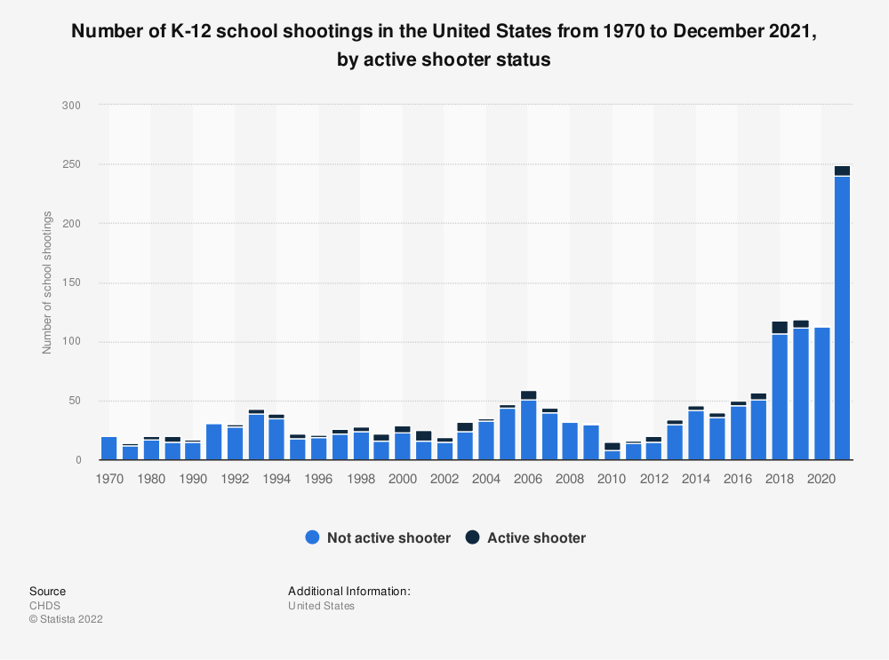

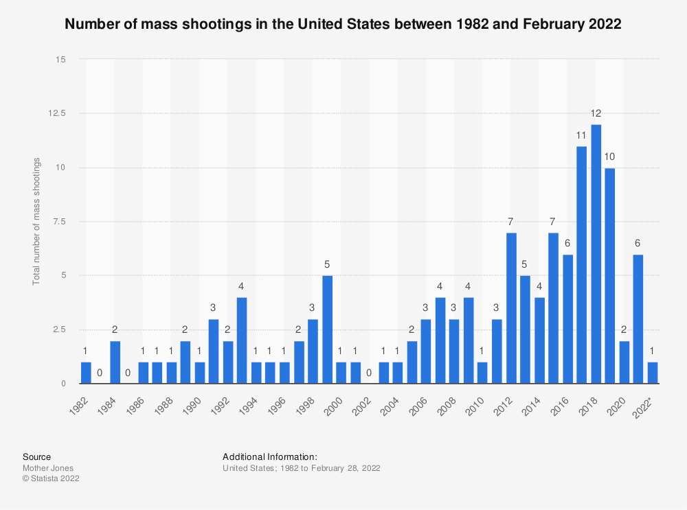

* Source:https://www.justice.gov/crt/combating-post-911-discriminatory-backlash-6
Department of Justice Hate Crimes:
The Civil Rights Division, the Federal Bureau of Investigation, and United States Attorneys offices have investigated over 800 incidents since 9/11 involving violence, threats, vandalism and arson against Arab-Americans, Muslims, Sikhs, South-Asian Americans and other individuals perceived to be of Middle Eastern origin. The incidents have consisted of telephone, internet, mail, and face-to-face threats; minor assaults as well as assaults with dangerous weapons and assaults resulting in serious injury and death; and vandalism, shootings, arson and bombings directed at homes, businesses, and places of worship.
Federal charges have been brought against 54 defendants, with 48 convictions to date. Additionally, Civil Rights Division attorneys have coordinated with state and local prosecutors in 150 non-federal criminal prosecutions, often providing substantial assistance.
Some of our prosecutions include:
Murfreesboro, TN: On July 18, 2012, the Division filed a complaint and motion for temporary restraining order and preliminary injunction against Rutherford County, TN for violations of the Religious Land Use and Institutionalized Persons Act (RLUIPA) 42 U.S.C. Â§ 2000cc because the county refused to inspect for and issue a certificate of occupancy to the Islamic Center of Murfreesboro. A Tennessee state chancery court ruled, on May 29, 2012, that the County improperly approved plans for the Islamic Center of Murfreesboro, and ordered on June 13, 2012, that Rutherford County may not issue a certificate of occupancy to the Center, which the center sought on July 13, 2012 and was denied on July 16, 2012. The Federal District Court for the Middle District of Tennessee issued a temporary restraining order against the county that will allow the Islamic Center to open their new mosque in time for Ramadan, provided the building passes inspection.
Minneapolis, Minnesota: On August 10, 2011, a former employee of the Transportation Security Administration (TSA), George Thompson, pleaded guilty to federal hate crime charges for assaulting an elderly Somali man in May 2010. Thompson admitted that he assaulted the man because he believes he was Muslim and Somali, and that he yelled to the victim during the assault that he should go back to Africa.
Arlington, Texas: On February 23, 2011, Henry Clay Glaspell pleaded guilty to violating the Church Arson Prevention Act by setting fire to a playground outside a mosque in July 2010. Glaspell will be sentenced on September 19.
Columbia, Tennessee: Three Tennessee men, Jonathan Edward Stone, Michael Corey Golden, and Eric Ian Baker, pleaded guilty to spray painting swastikas and “white power” on a mosque in Columbia, Tennessee, and then starting a fire that completely destroyed the mosque. In 2009 Golden and Baker were sentenced to more than 14 and 15 years in prison, respectively. On April 22, 2010, Stone was sentenced to more than 6 years in prison for his role in the crime.
Washington, D.C.: Patrick Syring pleaded guilty on June 12, 2008, to sending several email and voice mail threats to the Director of the Arab American Institute, as well as staff members, at their office in Washington, D.C. in 2006. On July 11, 2008, Syring was sentenced to 12 months in prison followed by 3 years of supervised release, as well as 100 hours of community service and a $10,000 fine.
Burbank, Illinois: Eric Kenneth Nix pleaded guilty on March 6, 2006, to blowing up the van of a Palestinian-American family that was parked in front of the family’s home. Nix pleaded guilty to a felony violation of 42 U.S.C. Â§ 3631, which prohibits threats or violence that interfere with fair housing rights. He received a 15-month prison sentence on August 22, 2006. Daniel R. Alba, who provided Nix with the commercial fireworks device he used in the crime and then lied about it to federal investigators, received a sentence of six months home confinement on March 14, 2006.
El Paso, Texas: Antonio Nunez-Flores pled guilty on March 22, 2005, to throwing an incendiary device at the Islamic Center of El Paso Mosque. The device, commonly referred to as a “Molotov Cocktail,” scorched the ground but did not explode. Children who were playing nearby ran away as the device landed and shattered. A second device was found and extinguished before it could explode. On June 22, 2005, Nunez-Flores was sentenced to 171 months in prison.
Sacramento, California: Matthew John Burdick pled guilty to assaulting a federal employee while engaged in his official duties on May 28, 2003, for shooting and wounding a Sikh postal carrier with a high-powered pellet rifle. The victim sustained a severe injury to his neck that required surgery and caused him to miss several months of work. On September 17, 2003, Burdick was sentenced to 70 months in prison and ordered to pay $25,395 in restitution.
St. Petersburg, Florida: Four defendants obtained substantial prison sentences plotting to destroy the Islamic Education Center. On April 3, 2003, Dr. Robert Goldstein pled guilty to conspiracy to violate civil rights, attempted destruction of religious property, and firearms violations. Goldstein was sentenced to 151 months in prison. His wife, Kristi, had previously pled guilty to firearms violations and been sentenced to 37 months in prison. Dr. Michael Hardee pled guilty to conspiracy to violate civil rights, conspiracy to detonate explosive devices, and firearms violations, and was sentenced to 41 months in prison. A fourth defendant, Samuel Shannahan, pled guilty to a firearms offense and was sentenced to 56 months in prison.
Seattle, Washington: Patrick Cunningham pled guilty on May 9, 2002, for attempting, two days after September 11, 2001, to set fire to cars in the parking lot of Seattle’s Islamic Idriss Mosque. He then fired a gun at worshipers who exited the mosque, and then fled. He was apprehended by police after crashing his vehicle. On December 17, 2002, Cunningham was sentenced to 78 months incarceration.
Salt Lake City, Utah: James Herrick pled guilty to pouring gasoline on the wall of a Pakistani-American restaurant on September 13, 2001, and lighting it in an attempt to destroy the building. He was sentenced on January 7, 2002, to 51 months incarceration.

Video

https://youtu.be/e2T_lBtT4R8

Victim Impact: Listen and Learn - Jee Young's Story

Victim Impact: Listen and Learn (Hate Crime)
December 2008
Victim Impact: Listen and Learn
The video in this series (NCJ 223072) features the first-person account of Jee Young who shares her experience as victim of hate crime and the ripple effect that victimization can have on family members and the community at large. A companion online only training curriculum is also available and includes a two part facilitator manual and a participant workbook.

https://youtu.be/MnjdOMRMxTs

The International Terrorism Victim Expense Reimbursement Program
December 2014
OVC administers the International Terrorism Victim Expense Reimbursement Program (ITVERP), which reimburses eligible victims of acts of international terrorism that occur outside the United States for expenses incurred as a direct result of their victimization. Watch a short video on how ITVERP may provide financial assistance to victims of international terrorism and their families. In this video, you will hear how ITVERP can assist victims from individuals who have received ITVERP benefits.

https://youtu.be/oRaczE68Zqc

Helping Victims of Mass Violence and Terrorism: Recovery
April 2016

Helping Victims of Mass Violence and Terrorism
This 7-minute video depicts how victims experience recovery and resilience at their own pace and in their own ways, and also shows how recovery approaches can be varied depending on victims' needs. Recovery approaches can be non-traditional, varied, and community or individual-based. For more information, visit Helping Victims of Mass Violence and Terrorism: Planning, Response, Recovery, and Resources at http://ovc.gov/pubs/mvt-toolkit/index.html.

